Parents can help the Troop flourish in many different ways; as adult leaders, by serving on the Troop Committee, by sharing their knowledge and serving as merit badge counselors, or by helping with transportation and/or other needs to support our weekend activities.  Dream it! Plan it!  Do it!  Troop 156  Troop 156 is one of the oldest Boy Scout Troops in the area, and has a 55+ year history of excellence and service. To date, the Troop has over 156 Scouts who have earned the Rank of Eagle.  The Troop is a boy-led troop, offering a Scouting program with the emphasis on camping and outdoor skills. Our Scouts actively practice the leadership skills they’ll use as adults.  Achievement for THIS weekend:  Satisfactory performance and the Boys approval, makes you a Troop Committee Member and you will be invited into the Old Dawg Patrol. |  | CANDIDATE NAME  ___________________________________  Troop 156  Scoutmaster  Scott Boice 586.703.9828  Assistant Scoutmasters  Mike Antoski 586.321.3660  Brad Pollum 586.405.5141  Jon Spyradakis 586.596.9534  Committee Chair  Sara Tidrow 586.216.3547 | 2025    GEEZER MERIT BADGE  OLD DAWG PATROL  The Old Dawg Patrol invites you to join us in the Adventure of Scouting. The experience you share with your son and this Troop will blow you away. Whether you do the training and wear the uniform or just join the Troop on campouts – GET INVOLVED!! We need your help and your efforts will pay off. As an introduction to Boy Scout Camping, we CHALLENGE you to complete the Old Dawg “Geezer” Merit Badge this weekend!

  Address:  D-Bar-A Scout Ranch  880 E. Sutton Road  Metamora, MI 48455  ___________________________  New Scout / Geezer Merit Badge Weekend  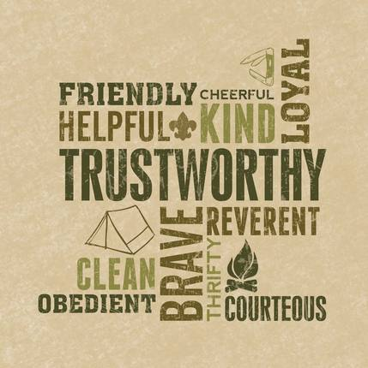 | Requirement Sign Off  Try to get some sleep.  Help create a duty roster.  Tour the Troop Trailer.  Talk to your Scout’s Patrol Leader or assist a Patrol Leader.  Use a latrine.  Assist a Scout that is not your Scout.  Set up a troop tent properly.  Relax by the camp fire or take a nap. | Requirement Sign Off  Learn and practice the “Leave No Trace” policy.  Ask a Scout about his favorite campout.  Learn how to use a compass.  Answer a question with – “I don’t know, ask you Patrol Leader.”  Wash your dishes in the cleaning station.  Witness a Scout using improper hygiene.  Participate in a camp service project (Do a good turn).  Participate in a Board of Review.

